Test for Appropriate Eldora Channel Spacing

The test was conducted by injecting 2 signals into the processor. One signal was a 60MHz stationary signal that represented the true channel. The second signal was stepped from 60MHz to 130MHz in 1MHz steps in order to mimic possible interference from another channel that could possibly leak into the true channel bandwidth. The A-Scope was used to display the frequency spectrum so that any spurs could be noted. To mimic the true system, the passive 60MHz filter was used which drastically helped to filter many of the added spurs due to the mixing of the interfering signal All of the spurs as well as their power in relation to full scale has been noted in an excel spreadsheet. There were 2 frequencies within the tested range that folded directly back into the 60MHz channel which were 84MHz and 108MHz. After an analysis of the inter-modulation products produced by the mixing phase of the down converter, the problem frequencies were caused by first order harmonics. No harmonics beyond the first order were observed. These frequencies as well as their immediate surrounding frequencies created problem areas which should not be used. It should also be noted that a spur of unknown origin existed at 56MHz. This spur was 10dB from the noise floor and was independent of frequency. However, with the presence of no input or a severely attenuated input, this spur was removed. This spur is also filtered from the spectrum in all cases including and exceeding 1/3us pulse width. For this reason, it is proposed to use 1/3us as the smallest pulse width for the radar.

This analysis proved that the Kaiser Filter was the limiting factor as to what frequencies would cause interference. This is because the Kaiser Filter operates at 48MSPS, maintains a fixed bandwidth, and is implemented directly after the mixing process. It effectively removes all interference within the 48MHz spectrum that is outside of its stop band. A fixed 3MHz Kaiser Filter bandwidth is proposed such that it will not interfere with the maximum bandwidth of the Gaussian Filter (1/3us PW = 1.5MHz BW). Figure 1 shows the channel spacing area of interest as well as the problem areas that alias back into the true channel at 60MHz.

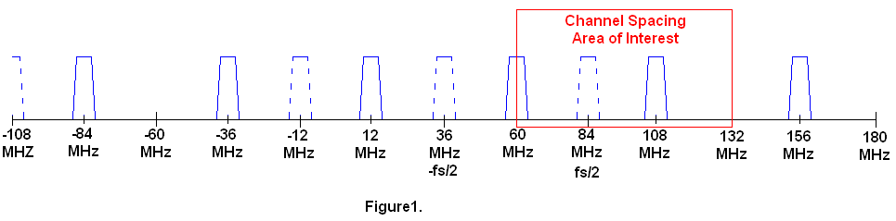

Because the Gaussian filter bandwidth changes with respect to the pulse width, the worse case filtering scenario can be observed with the smallest possible pulse width (1/3us PW = 1.5MHz BW). All Gaussian Filters were analyzed and this was confirmed. Table 1 shows the areas in which any interfering signal could be detected above the noise floor.

Bad BW (From) | Bad BW (To)
56 MHz | 64 MHz
80 MHz | 88 MHz
103 MHz | 111 MHz

Table 1.

Table 2 shows the list of possible channel spacings and which ones fall within one or more of the problem areas.

Ch Sep. | Ch1 Freq | Ch2 Freq | Ch3 Freq | Ch4 Freq
1 | 60 | 61 | 62 | 63
2 | 60 | 62 | 64 | 66
3 | 60 | 63 | 66 | 69
4 | 60 | 64 | 68 | 72
5 | 60 | 65 | 70 | 75
6 | 60 | 66 | 72 | 78
7 | 60 | 67 | 74 | 81
8 | 60 | 68 | 76 | 84
9 | 60 | 69 | 78 | 87
10 | 60 | 70 | 80 | 90
11 | 60 | 71 | 82 | 93
12 | 60 | 72 | 84 | 96
13 | 60 | 73 | 86 | 99
14 | 60 | 74 | 88 | 102
15 | 60 | 75 | 90 | 105
16 | 60 | 76 | 92 | 108
17 | 60 | 77 | 94 | 111
18 | 60 | 78 | 96 | 114
19 | 60 | 79 | 98 | 117
20 | 60 | 80 | 100 | 120
21 | 60 | 81 | 102 | 123
22 | 60 | 82 | 104 | 126
23 | 60 | 83 | 106 | 129
24 | 60 | 84 | 108 | 132
25 | 60 | 85 | 110 | 135

Table 2.

It can be seen by Table 2 that the only channel spacings available are 5MHz, 6MHz, 18MHz, and 19MHz. Due to the large pointing angle errors associated with larger channel spacings, the best choice would be 5MHz or 6MHz to minimize the pointing angle difference between channels. It should also be noted that this setup has the advantage of using fixed channel spacings that are independent of the pulse width. This would create fixed pointing angle errors that could be measured and calibrated for.

